**Project on**

Currency Converter

**Developed By:**

Abdurrahman Yaqub

**Reg NO:**

R213030200140

**NIIT**

**Currency Converter**

Batch code :

Start Date : 24th MAY,2021

End Date : 24th JUNE,2021

Name of coordinator : Mr. Christopher

Name of developer : Abdurrahman Yaqub

Date of submission : 24th  JUNE, 2021

**Acknowledgment**

I want express my special thanks to our instructor Mr. Christopher, as well as the management for giving me this opportunity to add this wonderful project on the topic Palm oil production database which has broadened my horizon of knowledge from researches and as such I’m able to handle similar tasks in the future. And to my friends who helped us a lot in finalizing this project within the limited time frame.

**Converter Page**

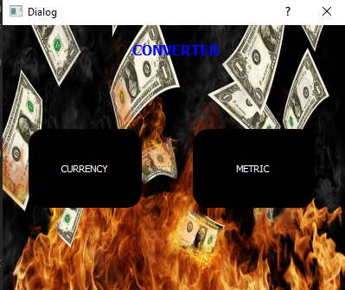

This is the page which you select what you want to convert, their are two options there either metric or currency.

**Currency Page**

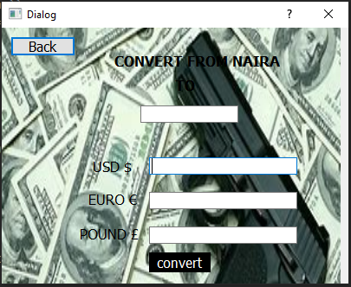

**Metric Page**

